**PROJECT X - AUTOMATED ATTENDANCE APP**

**Functional Testing**

Group Name:

May 15, 2025

**TRIPLE THREAT (+1)**

Submitted by:

**John Kenneth Gade**

**Cyril Lloyd Balanay**

**Ivan Vasay**

**Keynt Harly Adol**

Submitted to:

**Terry Watts**

**1. LOGIN**

* 1. **Login Failure:**

* 1. **Login Success**

**2. ADD USER (ADMIN)**

**2.1. Adding a New User**

**2.2. Add User Success**

**3. QR CODE VERIFICATION**

**3.1. QR Code Verification Success:**

**3.2. Attendance Record:**

**3.3 Invalid QR Code:**

**4. VIEWING ACTIVITY LOGS (ADMIN)**

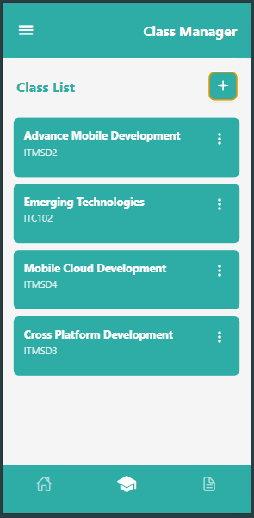**5. ADD CLASS (INSTRUCTOR):**

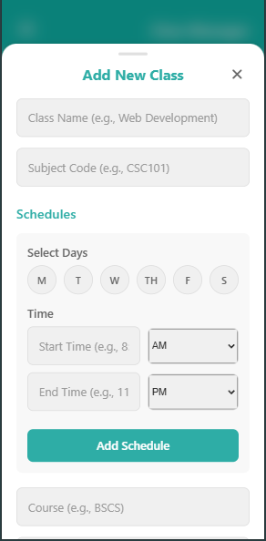**5.1 Adding A Class**

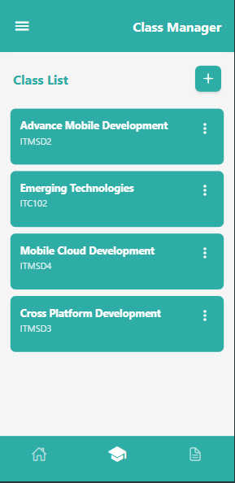**5.2 View Class List**

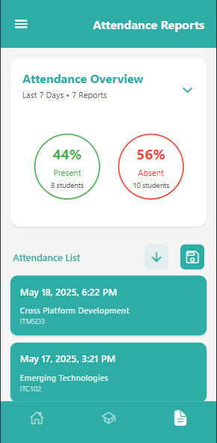**5.3 Attendance Reports**

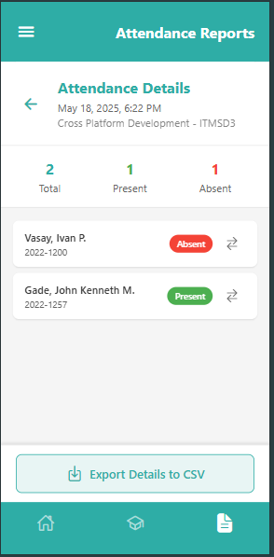**5.5 Attendance Reports**

**6 ADD STUDENT TO THIS SUBJECT:**

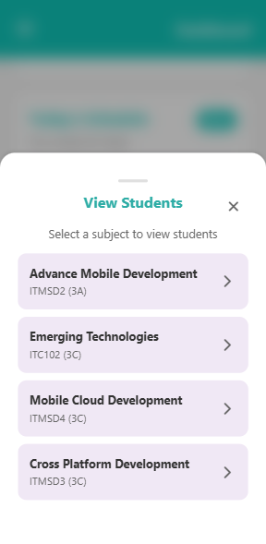

**6.1 ADD STUDENT**

